Magic Link Token

✨ What Is a Magic Link Token?
# Source: AI Source: Provided by: [Data Path: Persons Table -> ID Column: 1, Name_En Column: Motasem Essam] -> From: [Chatgpt (GPT‑5 Mini)] on [1/20/2026]
A Magic Link Token is a temporary, one-time-use token embedded in a special login link that lets a user log in without a password. It’s a secure and user-friendly alternative to traditional logins.

✅ Simple Definition:
# Source: AI Source: Provided by: [Data Path: Persons Table -> ID Column: 1, Name_En Column: Motasem Essam] -> From: [Chatgpt (GPT‑5 Mini)] on [1/20/2026]
A Magic Link lets users log in by clicking a link sent to their email or phone, instead of typing a password.
The token in the link is what verifies and logs them in.

🧠 Real-Life Analogy:
# Source: AI Source: Provided by: [Data Path: Persons Table -> ID Column: 1, Name_En Column: Motasem Essam] -> From: [Chatgpt (GPT‑5 Mini)] on [1/20/2026]
Imagine you go to a secure building:
- Instead of using a password or fingerprint
- You ring the doorbell, and they send you a one-time entry pass
- You click it, and the door opens — no password needed
That one-time pass = Magic Link Token.

🔄 How Magic Link Login Works
# Source: AI Source: Provided by: [Data Path: Persons Table -> ID Column: 1, Name_En Column: Motasem Essam] -> From: [Chatgpt (GPT‑5 Mini)] on [1/20/2026]
- User enters their email or phone number
- Backend generates a secure random token
- A login link is sent to
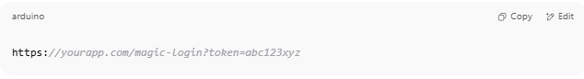
https://yourapp.com/magic-login?token=abc123xyz

- When the user clicks the link:
  - Backend verifies the token
  - If valid and unexpired → logs the user in automatically

🔑 Example Magic Link Token
# Source: AI Source: Provided by: [Data Path: Persons Table -> ID Column: 1, Name_En Column: Motasem Essam] -> From: [Chatgpt (GPT‑5 Mini)] on [1/20/2026]
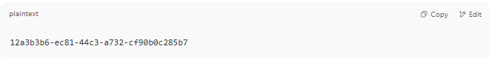
12a3b3b6-ec81-44c3-a732-cf90b0c285b7

It’s usually a UUID or hash — stored temporarily in your database along with:
- Expiry time (e.g., 10–30 minutes)
- User ID
- Status (used/unused)

🔐 Security Best Practices
# Source: AI Source: Provided by: [Data Path: Persons Table -> ID Column: 1, Name_En Column: Motasem Essam] -> From: [Chatgpt (GPT‑5 Mini)] on [1/20/2026]
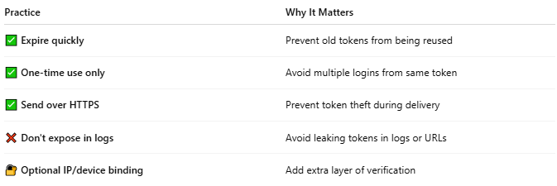

Practice | Why It Matters
✅ Expire quickly | Prevent old tokens from being reused
✅ One-time use only | Avoid multiple logins from same token
✅ Send over HTTPS | Prevent token theft during delivery
❌ Don't expose in logs | Avoid leaking tokens in logs or URLs
🔐 Optional IP/device binding | Add extra layer of verification

✅ When to Use Magic Links
# Source: AI Source: Provided by: [Data Path: Persons Table -> ID Column: 1, Name_En Column: Motasem Essam] -> From: [Chatgpt (GPT‑5 Mini)] on [1/20/2026]
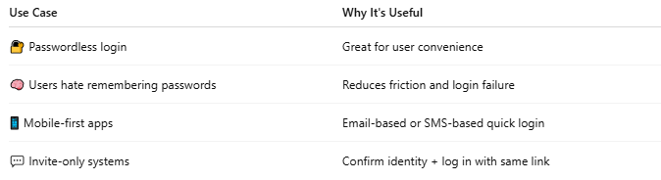

Use Case | Why It's Useful
🔐 Passwordless login | Great for user convenience
🧠 Users hate remembering passwords | Reduces friction and login failure
📱 Mobile-first apps | Email-based or SMS-based quick login
💬 Invite-only systems | Confirm identity + log in with same link

📌 Summary
# Source: AI Source: Provided by: [Data Path: Persons Table -> ID Column: 1, Name_En Column: Motasem Essam] -> From: [Chatgpt (GPT‑5 Mini)] on [1/20/2026]
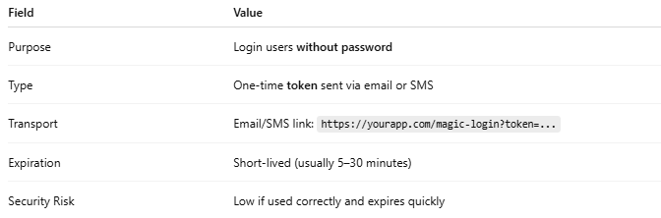

Field | Value
Purpose | Login users without password
Type | One-time token sent via email or SMS
Transport | Email/SMS link: https://yourapp.com/magic-login?token=...
Expiration | Short-lived (usually 5–30 minutes)
Security Risk | Low if used correctly and expires quickly

⚠️ Magic Link ≠ Email Verification
# Source: AI Source: Provided by: [Data Path: Persons Table -> ID Column: 1, Name_En Column: Motasem Essam] -> From: [Chatgpt (GPT‑5 Mini)] on [1/20/2026]
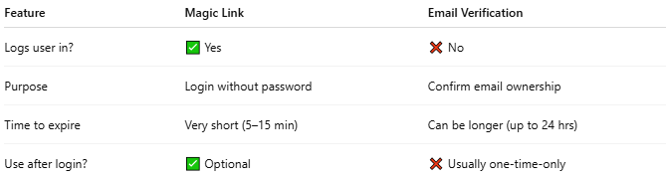

Feature | Magic Link | Email Verification
Logs user in? | ✅ Yes | ❌ No
Purpose | Login without password | Confirm email ownership
Time to expire | Very short (5–15 min) | Can be longer (up to 24 hrs)
Use after login? | ✅ Optional | ❌ Usually one-time-only

